CS 4335 Tutorial 10

Question 1: Use Edmon-Karp’s algorithm to compute the maximum flow for the following graph.
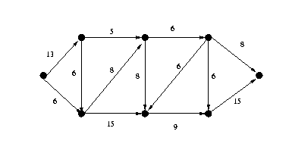
Question 2: Compute maximum bipartite matching for the following graph.

